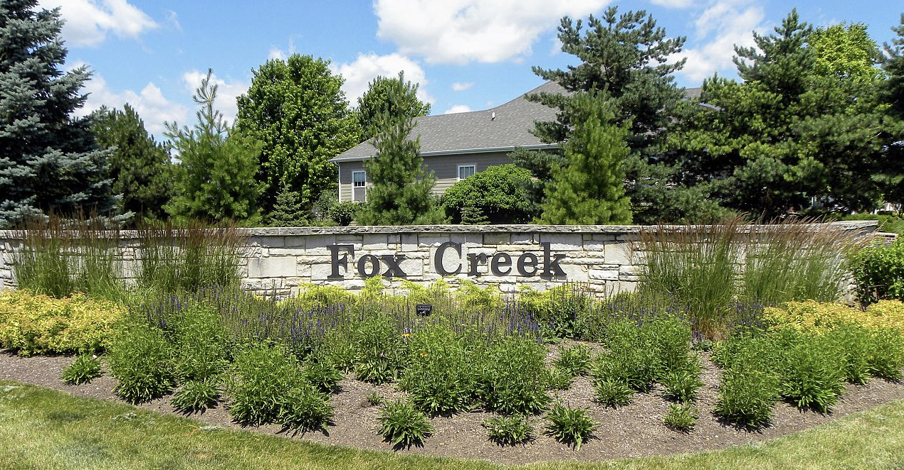

**FOX CREEK PROPERTY OWNERS’ ASSOCIATION**

**COMMUNITY DIRECTORY**

July 7, 2024

**WEBSITE: HOAFOXCREEK.COM**

**EMAIL:** [**hoafoxcreek@gmail.com**](mailto:hoafoxcreek@gmail.com)

**Government:**

**Animal Control 630-232-3555**

**Campton Township 630-387-1016**

**City of St Charles 630-377-4400**

**Village of Campton Hills 630-584-5700**

**Kane County Government 630-232-3400**

**Voter Registration 630-232-5990**

**State of IL Vehicle License & Reg** [**www.cyberdriveillinois.com**](http://www.cyberdriveillinois.com)

**Police:**

**Police and Fire Non-Emergency 630-584-0330**

**Police and Fire Emergency 911**

**Utilities:**

**Comcast 800-226-2278**

**Commonwealth Edison 800-334-7661**

**JULIE (Before you dig) 800-892-0123**

**Wasco Sanitary District 630-443-0111**

**Lakeshore Recycling 630-377-7000**

**Nicor 888-642-6748**

**Post Office:**

**Wasco Post Office 630-584-7299**

**Medical:**

**Fox Valley Urgent Care 630-499-1900**

**Delnor Community Hospital 630-208-3000**

**Poison Control 800-222-1222**

**Schools:**

**Wasco Elementary School 331-228-2900**

**Thompson Middle School 331-228-3100**

**St Charles North High School 331-228-4400**

|  |  |  |
| --- | --- | --- |
| **Name/Address** | **Email** | **Phone** |
| **Ackman, Dustin & Stacy**  **40W668 Fox Creek Drive** | [**dustinackman@gmail.com**](mailto:dustinackman@gmail.com)  [**stacyackman@gmail.com**](mailto:stacyackman@gmail.com) | **224-545-6364**  **630-707-9415** |
| **Bhattacharyya, Bikash & Moumita** | [**bikash@yahoo.com**](mailto:bikash@yahoo.com)  [**Moumitbh@gmail.com**](mailto:Moumitbh@gmail.com) |  |
| **Berke, Chris & Erin O’Malley**  **4N656 Old LaFox Rd** | [**cberke@nowway.com**](mailto:cberke@nowway.com) | **847-308-4069** |
| **Bettini, Michale & Heather**  **40W634 Blue Lake Circle N** | [**Bettini@comcast.net**](mailto:Bettini@comcast.net) | **630-808-4461**  **630-973-0929** |
| **Beyer, Chris & Shannon**  **4N642 Blue Lake Circle E** |  | **630-636-1350** |
| **Bihun, Thomas & Nora**  **4N642 Blue Lake Circle** |  | **630-587-3107** |
| **Brauer, Jerry & Christine**  **40W917 Fox Creek Dr** | [**Gweat41@aol.com**](mailto:Gweat41@aol.com)  [**Wasco88@aol.com**](mailto:Wasco88@aol.com) | **309-530-2802** |
| **Campos, Nick & Isabel** | [**Chaidezcampos2018@gmail.com**](mailto:Chaidezcampos2018@gmail.com) |  |
| **Carlson, Mark & Vanessa**  **40W555 Fox Creek Dr** | [**markarlson@gmail.com**](mailto:markarlson@gmail.com) | **312-671-6275** |
| **Cook, Trevor & Courtney**  **40W714 Fox Creek Dr** | [**courtneylcook@gmail.com**](mailto:courtneylcook@gmail.com)  [**cook.trevor19@gmail.com**](mailto:cook.trevor19@gmail.com) | **630-456-3759**  **312-433-9076** |
| **Dantinne, Matt & Michelle**  **40W757 Fox Creek Dr** | [**Dantinne0695@gmail.com**](mailto:Dantinne0695@gmail.com) | **331-442-9670** |
| **Davila, Florentino & Nelly** | [**Tdavila12@yahoo.com**](mailto:Tdavila12@yahoo.com) |  |
| **DeMeyer, Dan & Laurie**  **40W805 Ellis Johnson Ln** | [**dldemeyer@comcast.net**](mailto:dldemeyer@comcast.net) | **630-800-5489**  **630-849-8638** |
| **Derrico, Terry & Kris**  **40W838 Ellis Johnson Ln** | [**derricok@gmail.com**](mailto:derricok@gmail.com) | **630-945-3163** |
| **Farrand, Michael & Jayne**  **4N687 Blue Lake Circle W** | [**Jurzgurl3@yahoo.com**](mailto:Jurzgurl3@yahoo.com) | **630-443-0550** |
| **Gentile, Gregory & Kelly**  **06N825 Old LaFox Rd** | [**Kscheer123@yahoo.com**](mailto:Kscheer123@yahoo.com)  [**Gentile8328@gmail.com**](mailto:Gentile8328@gmail.com) | **815-980-6632** |
| **Gill, Mike & Sharon**  **40W775 Ellis Johnson Ln** | [**Sgillpic5@gmail.com**](mailto:Sgillpic5@gmail.com) | **815-441-3673**  **815-622-8762** |
| **Grist, Debbie**  **40W908 Fox Creek Dr** |  | **630-649-8000** |
| **Hintz, Kurt & Erika**  **4N755 Blue Lake Circle** | [**khintz@performanceservices.com**](mailto:khintz@performanceservices.com) | **847-875-7055** |
| **Hoffrage, Kelly**  **Knutsch, Brian**  **4N696 Blue Lake Circle E** | [**khoffrage@yahoo.com**](mailto:khoffrage@yahoo.com) | **630-212-6368** |
| **Jacobsen, Terri**  **Rizzi, Dimitra**  **40W802 Fox Creek Dr** | [**terriljacobsen@gmail.com**](mailto:terriljacobsen@gmail.com)  [**Dimitra.rizzi@gmail.com**](mailto:Dimitra.rizzi@gmail.com) | **708-655-1435**  **630-391-8625** |
| **Joniak, Darryl & JoAnn**  **40W593 Blue Lake Circle N** | [**djoniak@sbcglobal.net**](mailto:djoniak@sbcglobal.net) | **630-881-1614** |
| **Kistner, John & Mary**  **4N658 Blue Lake Circle E** | [**kistnerj@comcast.net**](mailto:kistnerj@comcast.net)  [**mtfaillo@comcast.net**](mailto:mtfaillo@comcast.net) | **630-715-1710**  **630-430-7845** |
| **Kraft, Kevin & Terri**  **40W725 Ellis Johnson Ln** | [**Tkraft725@comcast.net**](mailto:Tkraft725@comcast.net) | **630-464-3729** |
| **Kuester, Andy & Caryn**  **40W767 Fox Creek Dr** | [**Akuester516@gmail.com**](mailto:Akuester516@gmail.com)  [**ckdesignrep@gmail.com**](mailto:ckdesignrep@gmail.com) | **630-442-2122**  **847-322-8805** |
| **Kyle, Joseph & Lisa**  **40W574 Blue Lake Circle N** | [**Joe.kyle@att.net**](mailto:Joe.kyle@att.net)  [**Lisa_kyle@att.net**](mailto:Lisa_kyle@att.net) | **847-778-6597**  **847-778-6598** |
| **Leonard, Troy & Kris**  **4N731 Blue Lake Circle E** | [**Kleonards535@gmail.com**](mailto:Kleonards535@gmail.com) | **412-537-6201** |
| **Liu, Chang**  **Niu, Juliet**  **40W689 Fox Creek Dr** | [**Changliu99@gmail.com**](mailto:Changliu99@gmail.com) | **815-751-6268** |
| **Majjiga, Thirupathi**  **40W715 Ellis Johnson Ln** | [**tmajjiga@gmail.com**](mailto:tmajjiga@gmail.com) | **815-999-7956** |
| **Mangini, Stephanie** | [**Scole1939@gmail.com**](mailto:Scole1939@gmail.com) | **331-301-6213** |
| **Marshall, Todd & Kelli**  **40W867 Fox Creek Dr** | [**Kelmarshall180@gmail.com**](mailto:Kelmarshall180@gmail.com) | **630-219-9613** |
| **McAleese, Jim & Nicole** | [**jim@mmtravel.org**](mailto:jim@mmtravel.org) |  |
| **McCowan, William & Sue**  **40W787 Fox Creek Dr** |  | **630-549-0327** |
| **McKelvie, Jim & Jennifer**  **40W937 Fox Creek Dr** | [**packerwin@gmail.com**](mailto:packerwin@gmail.com) | **630-248-4928** |
| **Moldovan, Matt & Tracee**  **40W848 Ellis Johnson Ln** | [**Matt.moldovan@mattel.com**](mailto:Matt.moldovan@mattel.com)  [**Traceemoldovan@yahoo.com**](mailto:Traceemoldovan@yahoo.com) | **248-346-0035**  **219-916-4552** |
| **Mueller, Megan and Rich**  **40W548 Settlement Drive** | **meganmueller73@gmail.com** | **760-450-4548** |
| **Niehus, Barrett & Rebecca** | [**bniehus@me.com**](mailto:bniehus@me.com) |  |
| **Okpala, Martin & Alicia**  **40W877 Fox Creek Dr** | [**Mcokpala84@gmail.com**](mailto:Mcokpala84@gmail.com)  [**Arokpala@gmail.com**](mailto:Arokpala@gmail.com) | **773-704-5001** |
| **Ray, Andrea & Ryan**  **4N626 Old LaFox Rd** | [**Ryan_ray2020@yahoo.com**](mailto:Ryan_ray2020@yahoo.com)  [**Armazzu626@yahoo.com**](mailto:Armazzu626@yahoo.com) | **847-224-3871**  **630-287-1222** |
| **Ren, Lina**  **Ma, Chunyu** | [**freshlinaren@gmail.com**](mailto:freshlinaren@gmail.com) | **917-618-9822** |
| **Salter, Cody**  **4N608 Blue Lake Circle E** | [**Cody.salter@gmail.com**](mailto:Cody.salter@gmail.com) | **630-347-8900** |
| **Salyards, Vince & Ellen**  **40W727 Fox Creek Dr** | [**evsalyards@comcast.net**](mailto:evsalyards@comcast.net) | **630-207-7710** |
| **Schertz, Jeff & Cassie**  **40W602 Blue Lake Circle N** | [**jcschertz@sbcglobal.net**](mailto:jcschertz@sbcglobal.net) | **708-927-3510** |
| **Schuler, Jim & Debbie**  **4N628 Blue Lake Circle N** | [**debmschu@aol.com**](mailto:debmschu@aol.com) | **815-238-3361** |
| **Seaman, Garrett & Kim**  **40W817 Fox Creek Dr** | [**g.wm.seaman@gmail.com**](mailto:g.wm.seaman@gmail.com) | **217-246-3538** |
| **Shearon, Matt & Diane**  **40W847 Ellis Johnson Ln** | [**dianegibala@hotmail.com**](mailto:dianegibala@hotmail.com)  [**matthewmshearon@gmail.com**](mailto:matthewmshearon@gmail.com) | **630-301-9250** |
| **Skidmore, Tim & Angie**  **40W587 Fox Creek Dr** | [**teskids@gmail.com**](mailto:teskids@gmail.com)  [**adbogacki@yahoo.com**](mailto:adbogacki@yahoo.com) |  |
| **Spence, Jeff & Chris**  **40W732 Fox Creek Dr** | [**Spencemom4@yahoo.com**](mailto:Spencemom4@yahoo.com) | **440-554-6352** |
| **Tippett, Roger & Laura**  **4N734 Blue Lake Circle E** | [**rjatippett@gmail.com**](mailto:rjatippett@gmail.com)  [**lhtippett@gmail.com**](mailto:lhtippett@gmail.com) | **630-797-5372**  **630-338-7979** |
| **Totman, Mary & Tim**  **4N606 Old LaFox Rd** | [**timmytots@comcast.net**](mailto:timmytots@comcast.net) | **630-945-3321** |
| **True, Kevin & Sandy**  **40W798 Ellis Johnson Ln** | [**Ktrue1208@comcast.net**](mailto:Ktrue1208@comcast.net)  [**Strue1027@comcast.net**](mailto:Strue1027@comcast.net) | **630-240-0437**  **630-248-7518** |
| **Underkofler, Jason & Tara**  **40W745 Ellis Johnson Ln** | [**Jason.underkofler@gmail.com**](mailto:Jason.underkofler@gmail.com)  [**taraunderkofler@gmail.com**](mailto:taraunderkofler@gmail.com) |  |
| **Utter, Lance & Stephanie**  **4N655 Blue Lake Circle E** | [**lanceutter@gmail.com**](mailto:lanceutter@gmail.com)  [**skutter98@gmail.com**](mailto:skutter98@gmail.com) |  |
| **Van Camp, Brad & Dana**  **40W605 Fox Creek Dr** | [**Bradleyalan.vancamp@gmail.com**](mailto:Bradleyalan.vancamp@gmail.com)  [**Dana_vancamp@yahoo.com**](mailto:Dana_vancamp@yahoo.com) | **847-401-7482**  **847-401-7932** |
| **Weis, Rod & Roz**  **40W752 Fox Creek Dr** | [**Rosalynweis9@gmail.com**](mailto:Rosalynweis9@gmail.com)  [**weisrp@gmail.com**](mailto:weisrp@gmail.com) | **630-715-0705**  **331-224-0157** |
| **Welsh, Barry & Ashley**  **40W818 Ellis Johnson Ln** | [**Barrywelsh99@gmail.com**](mailto:Barrywelsh99@gmail.com) |  |
| **West, Scott & Marie**  **40W898 Fox Creek Dr** | [**Packerfan63@sbcglobal.net**](mailto:Packerfan63@sbcglobal.net)  [**mstitzcabi@gmail.com**](mailto:mstitzcabi@gmail.com) | **847-533-5697**  **847-971-8444** |
| **Wick, Curt & Katie**  **40W868 Fox Creek Dr** | [**Curt.wick@hotmail.com**](mailto:Curt.wick@hotmail.com) | **847-812-8384**  **815-219-0858** |
| **Wilder, Jeff & Kristi**  **4N708 Blue Lake Circle E** | [**Wildjw1@yahoo.com**](mailto:Wildjw1@yahoo.com)  [**Wildjk1@aol.com**](mailto:Wildjk1@aol.com) | **630-886-7552 Jeff**  **630-886-6693 Kristi** |
| **Winkates, John & Kathy**  **40W713 Fox Creek Dr** | [**winkates@sbcglobal.net**](mailto:winkates@sbcglobal.net) | **847-826-1391** |
| **Wolff, Woody, Kartheiser, Jordan**  **4N735 Blue Lake Circle W** | [**Woodyww7@gmail.com**](mailto:Woodyww7@gmail.com) |  |
| **Woeste, Pete & Christine**  **4N653 Blue Lake Circle W** | [**petergwoeste@gmail.com**](mailto:petergwoeste@gmail.com) | **773-459-7791**  **630-217-5662** |